ypically experiences, then add detail to each of the other rows.

SCENARIO

##### Entice

Enter

Engage Exit Extend

Browsing, booking, attending, and rating a local city tour

How does someone initially become aware of this process?

What do people experience as they begin the process?

In the core moments in the process, what happens?

What do people What happens after the

typically experience experience is over?

as the process inishes?

###### Steps

What does the person (or group)

instant gradation

decision depends

Talk to compares the

puts training

typically experience?

see demos st

information needs to

is important after a

on community and

neighbours possibilities of into practice

community center

be shared easily

large purchase family support

current independently

###### Interactions

What interactions do they have at each step along the way?

People: Who do they see or talk to?

interaction with

information

information that can be shared

increasing global

impacts on environment

Final

sales & purchase

training programs, Independent & reference

Places: Where are they? salesman at demo

Things: What digital touchpoints or physical objects would they use?

###### Goals & motivations

provided at demo

with others

population

preferences for

expectation on

process materials

At each step, what is a person’s

primary goal or motivation?

### potential user who

completing

content

#### Receive training and

(“Help me...” or “Help me avoid...”)

### know about the service

Learning

setting criteria for Final purchase decision

sources of complete purchase

### information

#### support as needed

###### Positive moments

What steps does a typical person ind enjoyable, productive, fun,

building aware of estimate

### customer who have used more

empowered

accomplished

motivating, delightful, or exciting?

Excitement

excitement & interest

Interested

at the moment

number of times

proud

###### Negative moments

What steps does a typical person ind frustrating, confusing, angering,

information was not some information

# lack of

nervous and

## difficult for

costly, or time-consuming?

### clear the first time

was confusing busy,

## family doubt

Financing

customer to

overwhelmed, over investment

### conflicted

opportunities

made of doubt train others

###### Areas of opportunity

How might we make each step better? What ideas do we have? What have others suggested?

agronomy the science and technology of

Information needs to be easily shared

outside demos & nanotechnology

conversation

Agricultural

# legume

##### producing

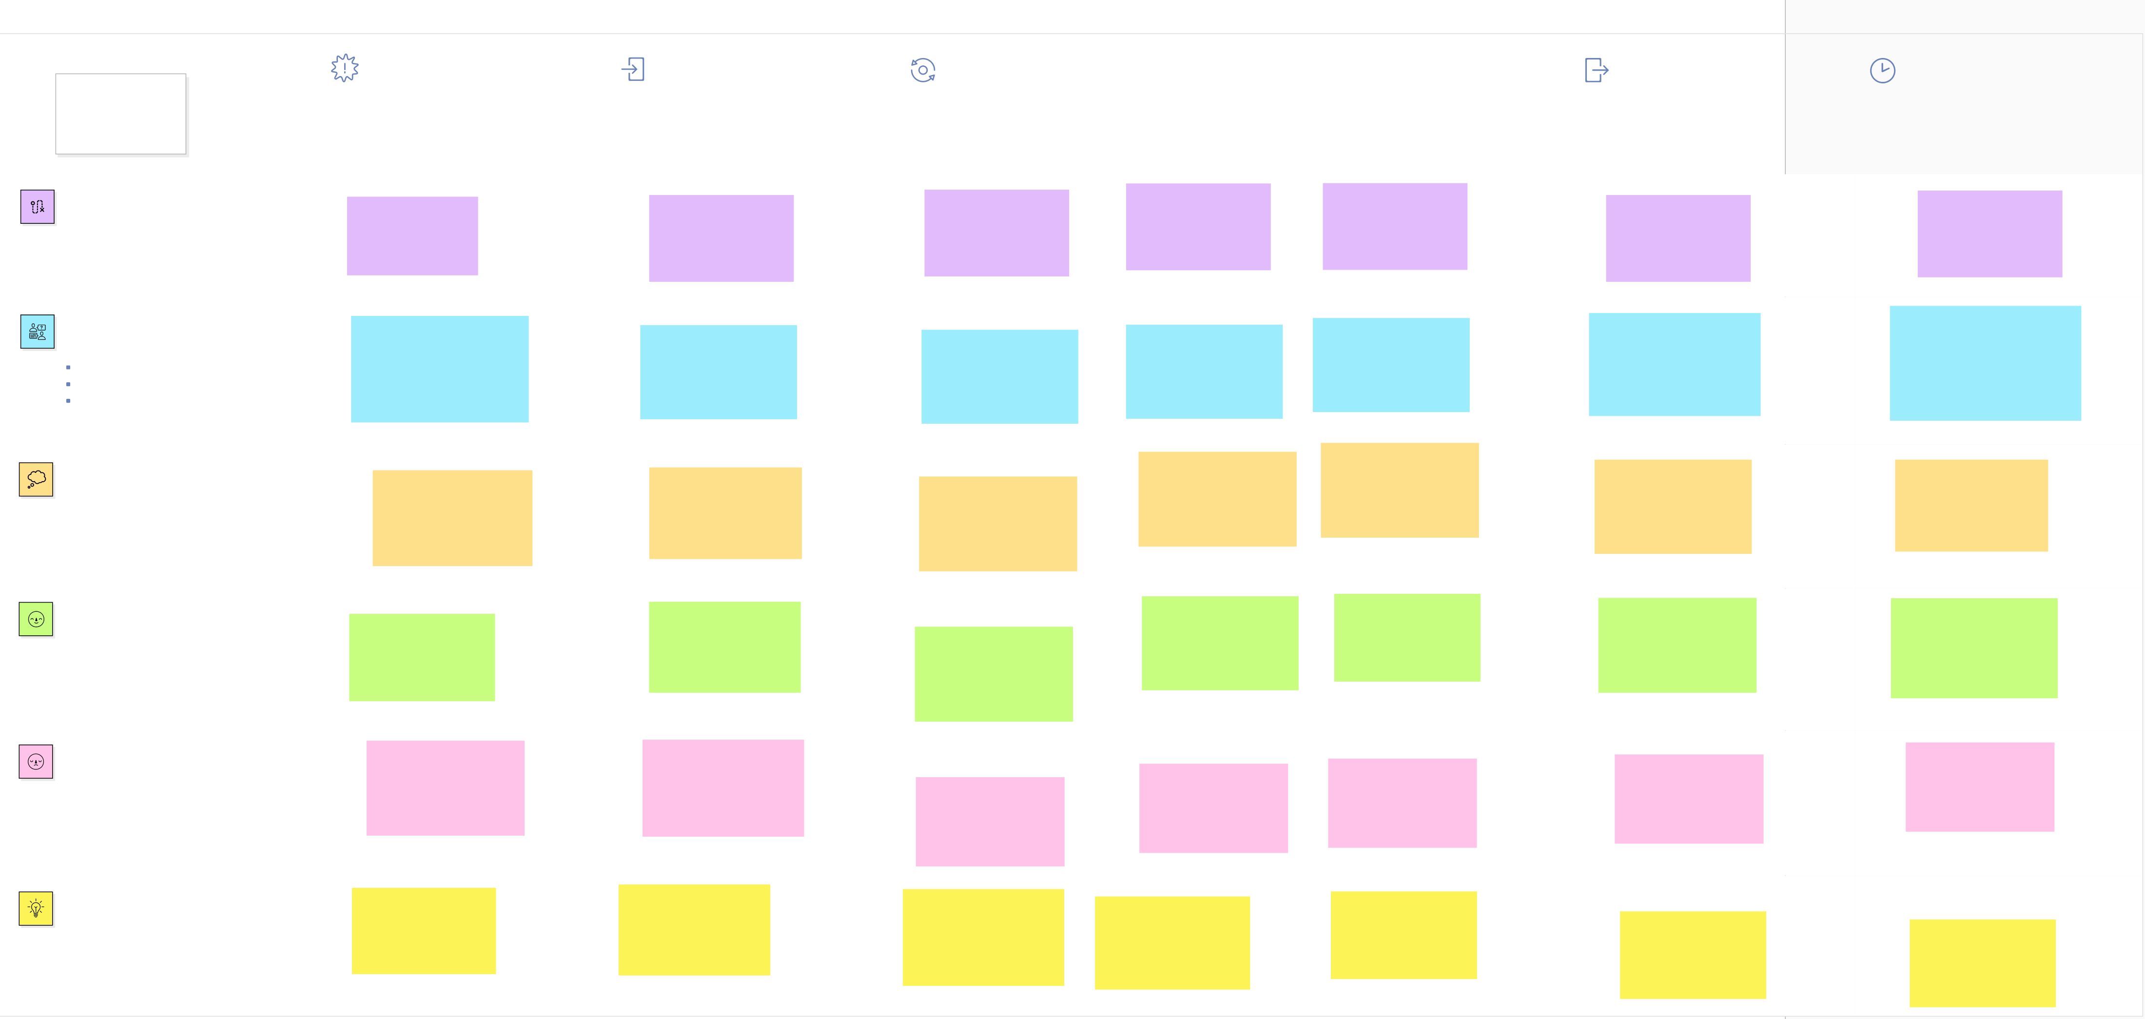

workshops planner economist

# rotation

agriculture

engineer